**s o f i a**

**Test and Integration Plan**

**Document Control**

|  |  |  |
| --- | --- | --- |
| **Editor** | **Date** | **Update** |
| **Samuel Raeburn** | **08/03/2015** | **Document created** |
| **Samuel Raeburn** | **12/03/2015** | **Document edited** |
|  |  |  |

**Table of Contents**

1.0 Final Test and Integration Plan 4

**Final Test and Integration Plan**

# Final Test and Integration Plan

This document describes which modules of code need to be tested and when by in order for a high quality piece of software to be produced by the deadline.

The software development can be described using discrete sections of code – referred to as modules - which when integrated together form the finished products; TeachEasy and LearnEasy.

In order to ensure a high quality product these modules will be tested both independently and after they have been integrated. Independent tests ensure that all the required functionality is present and working as required. Integration testing ensures that new modules work as intended alongside existing code. Regression testing will also be used to ensure that no previously implemented functionality is lost due to the addition of code. The development process has been split into 2 releases, with each release comprising of 2 iterations. Therefore in total there are 4 iterations. At the end of the first release a student will be able to interact with a previously created lesson. The second release adds the functionality for a teacher to create lessons.

A list of all of the modules of code and when they need to be tested and integrated is shown in figure 1. The same information is conveyed using a GANTT chart in figure 2.

The customer has set a strict deadline for the completion of this product so it is important that the dates set in figure 1 are adhered to. These dates were produced by working backwards from the deadline set by the customer. As outlined in the QA manual testing will occur during the implementation of software, essentially in parallel to the development. Sofia believes that testing early and testing often is a key aspect of the production of high quality software.

At the time of completion of the first version of this document (week 10 of Spring term) testing of the software is running to schedule. Both the XML parser and writer were tested thoroughly as they are crucial to the product. Some changes may need to be made to the XML parser and writer in the future but this will be tested as and when it happens.

The deadline for the testing and integration of the media handlers is not the same for all of them. The graphics and text handlers are being outsourced and they are not due to be finished until week 1 of the summer term, there is then a 10 day warranty period in which we can contact the company responsible for producing them and report any bugs, hence the integration completion date of week 2 of the summer term.

The integration deadline for the audio and video handlers is a week later than the other handlers this is partly because they are more complex and thus more prone to bugs but also because we are selling them to another company. Any software sold by us to another company should be as close to bug free as possible, this will help to retain the good reputation of sofia. It is also important financially since it is stated in the contract that if the client finds any bugs they will be appropriately reimbursed.

Upon completion of release 1, a demo was shown to the customer, giving them the opportunity to supply feedback on progress so far and request any changes. The only feedback received was that the GUI needs more attention; this has been taken into account.

Iteration 4 mainly focusses on adding additional functionalities to LearnEasy and TeachEasy, it is not easy to estimate how long this will take but they will be tested in parallel to ensure that all of the software included in the release is reliable.

All software development should be completed by week 6 of the summer term, allowing the company an additional week for testing and some time to focus on any presentations necessary for the marketing of the product. If this plan is adhered to, the product will be completed by the deadline.

|  |  |  |  |  |  |
| --- | --- | --- | --- | --- | --- |
| Iteration | Piece of software | Date of module being tested | | Date of module being integrated and tested | |
|  | | **Term** | **Week** | **Term** | **Week** |
| Iteration 1 | XML Parser | Spring | 6 | Spring | 7 |
| Iteration 1 | XML Writer | Spring | 6 | Spring | 7 |
| Iteration 1 | Data Structure | Spring | 7 | Spring | 8 |
| Iteration 2 | Image Handler | Spring | 8 | Spring | 9 |
| Iteration 2 | Audio Handler | Summer | 1 | Summer | 1 |
| Iteration 2 | Video Handler | Summer | 1 | Summer | 1 |
| Iteration 2 | Graphics Handler | Summer | 1 | Summer | 2 |
| Iteration 2 | Text Handler | Summer | 1 | Summer | 2 |
| Iteration 2 | Answer Box Handler | Spring | 8 | Spring | 9 |
| Iteration 2 | Multiple Choice Handler | Spring | 8 | Spring | 9 |
| Iteration 2 | Renderer | Spring | 8 | Spring | 9 |
| Iteration 2 | LearnEasy Runtime Data | Spring | 9 | Spring | 10 |
| Iteration 2 | LearnEasy GUI | Spring | 9 | Spring | 10 |
| Release 1 | | Spring | 9 | Spring | 10 |
| Iteration 3 | Extended Renderer | Summer | 2 | Summer | 3 |
| Iteration 3 | TeachEasy Runtime Data | Summer | 3 | Summer | 4 |
| Iteration 3 | LearnEasy Lesson Progress Tracking | Summer | 4 | Summer | 5 |
| Iteration 3 | LearnEasy Lesson Selection Menu | Summer | 4 | Summer | 5 |
| Iteration 4 | LearnEasy User Certificates | Summer | 5 | Summer | 6 |
| Iteration 4 | TeachEasy Lesson Templates | Summer | 5 | Summer | 6 |
| Iteration 4 | TeachEasy GUI | Summer | 5 | Summer | 6 |
| Final Testing | | Summer | 6 | Summer | 7 |
| Release 2 | | Summer | 7 | Summer | 8 |

*Figure 1 – A table showing the modules of code and their respective dates of completion.*

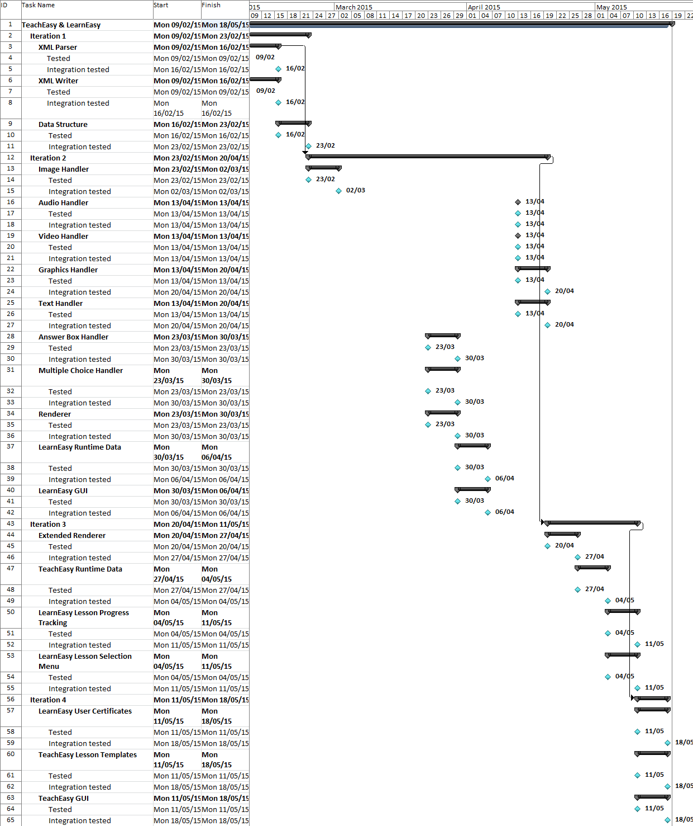Figure 2: GANTT chart showing the dates of completion of testing